 | DEPARTMENT OF FIRST YEAR ENGINEERING
PBLE Report
Semester | F.E. Semester II – Computer Engineering
Subject | Data Structure
Subject Professor In-charge | Prof. Swapnil S. Sonawane

Roll Number | Name of Students
25102C0050 | OMKAR SHINDE
25102C0047 | ADIT NAIK
25102C0032 | EASHAN TAMBOLI
25102C0046 | ATHARV ALEKAR

Name of the Project: LIBRARY BOOK MANAGEMENT SYSTEM

Project Description: Mnanages books by adding , deleting , searching , and displaying them .

Project Code:

#include <stdio.h>
#include <stdlib.h>

// Structure
struct Book {
int id;
char name[100];
char author[100];
struct Book* next;
};

struct Book* head = NULL;

// Add Book
void addBook() {
struct Book* newBook = (struct Book*)malloc(sizeof(struct Book));

printf("Enter Book ID: ");
scanf("%d", &newBook->id);

printf("Enter Book Name: ");
scanf(" %[^\n]", newBook->name);

printf("Enter Author Name: ");
scanf(" %[^\n]", newBook->author);

newBook->next = NULL;

if (head == NULL) {
head = newBook;
} else {
struct Book* temp = head;
while (temp->next != NULL) {
temp = temp->next;
}
temp->next = newBook;
}

printf("Book Added Successfully!\n");
}

// Display Books
void displayBooks() {
struct Book* temp = head;

if (temp == NULL) {
printf("No books available.\n");
return;
}

while (temp != NULL) {
printf("\nID: %d", temp->id);
printf("\nBook Name: %s", temp->name);
printf("\nAuthor: %s\n", temp->author);
temp = temp->next;
}
}

// Search Book
void searchBook() {
int id, found = 0;

printf("Enter Book ID to search: ");
scanf("%d", &id);

struct Book* temp = head;

while (temp != NULL) {
if (temp->id == id) {
printf("\nBook Found!\n");
printf("Book Name: %s\n", temp->name);
printf("Author: %s\n", temp->author);
found = 1;
break;
}
temp = temp->next;
}

if (found == 0) {
printf("Book not found.\n");
}
}

// Delete Book
void deleteBook() {
int id;

printf("Enter Book ID to delete: ");
scanf("%d", &id);

struct Book *temp = head, *prev = NULL;

if (temp != NULL && temp->id == id) {
head = temp->next;
free(temp);
printf("Book Deleted.\n");
return;
}

while (temp != NULL && temp->id != id) {
prev = temp;
temp = temp->next;
}

if (temp == NULL) {
printf("Book not found.\n");
return;
}

prev->next = temp->next;
free(temp);

printf("Book Deleted.\n");
}

// Main Function
int main() {
int choice;

do {
printf("\n--- Library Management System ---\n");
printf("1. Add Book\n");
printf("2. Display Books\n");
printf("3. Search Book\n");
printf("4. Delete Book\n");
printf("5. Exit\n");
printf("Enter choice: ");

scanf("%d", &choice);

switch (choice) {
case 1: addBook(); break;
case 2: displayBooks(); break;
case 3: searchBook(); break;
case 4: deleteBook(); break;
case 5: printf("Exiting...\n"); break;
default: printf("Invalid choice!\n");
}

} while (choice != 5);

return 0;
}

Output Screenshots:
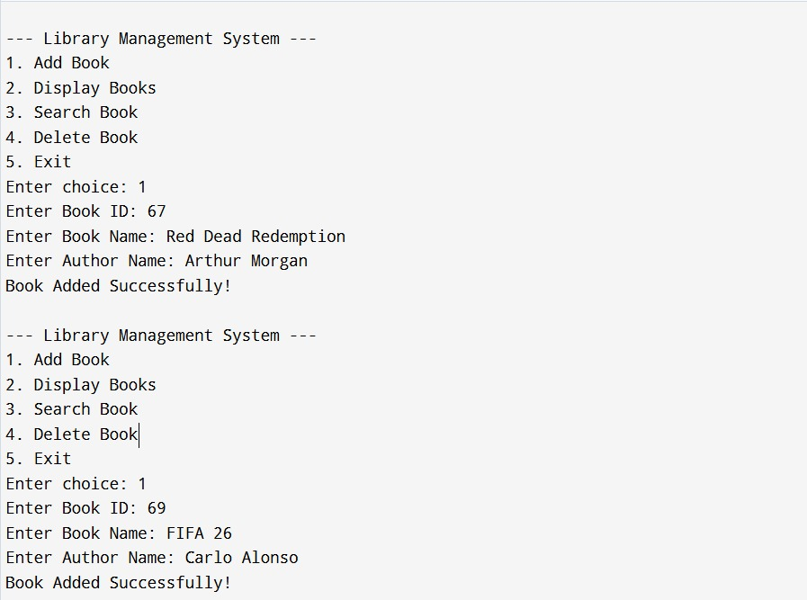

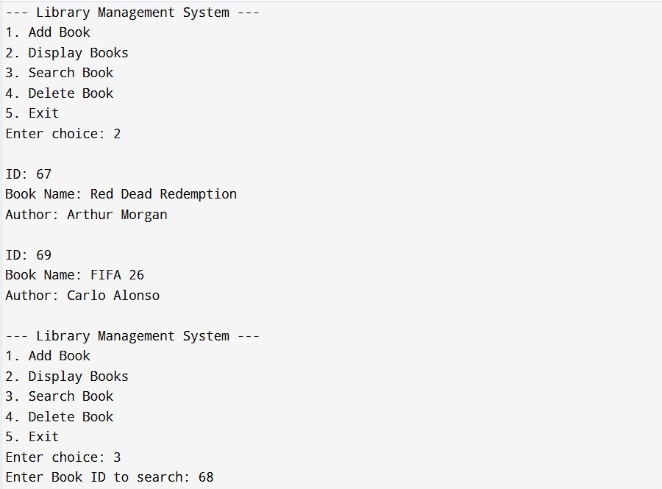

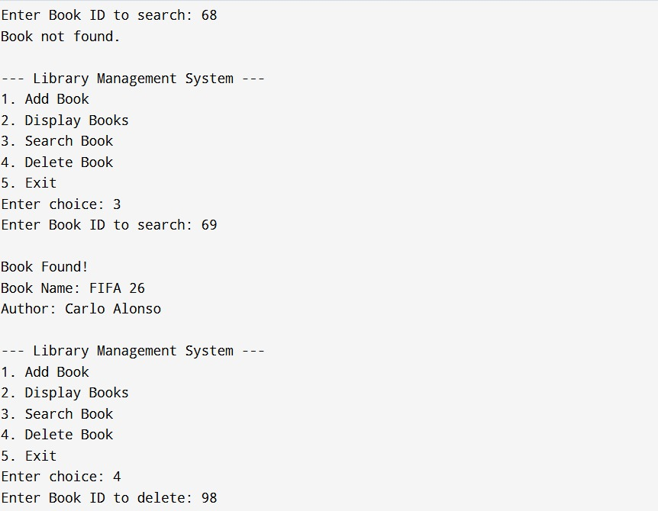

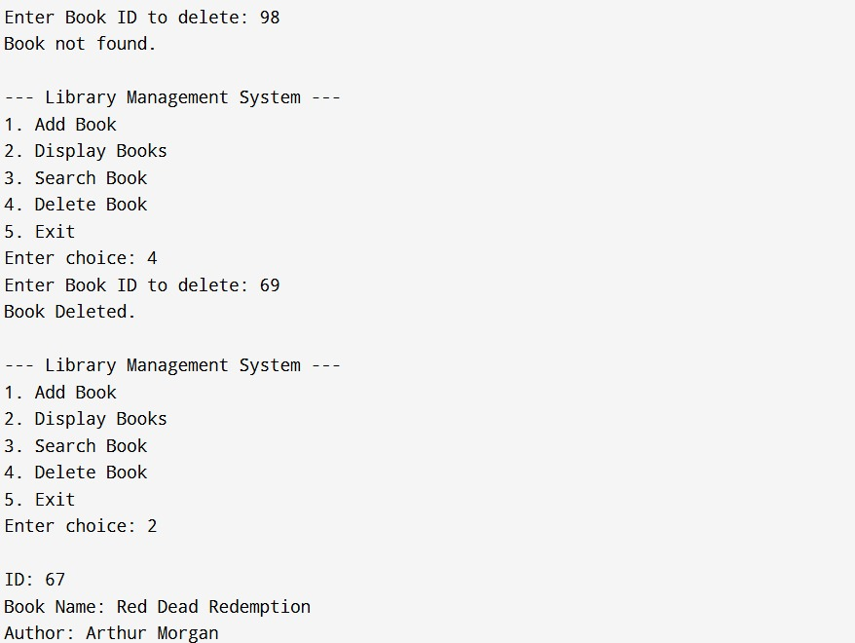

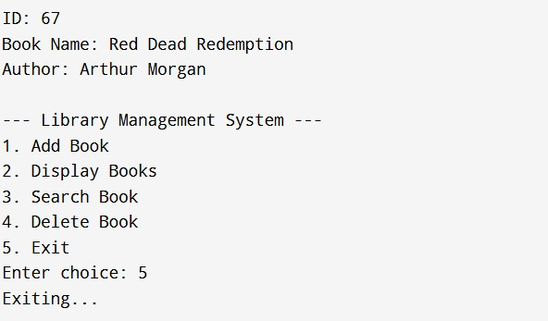

GitHub Public Repository Link:

